Software Documentation

1. Software Overview
The software controls the entire system by managing user input, lighting effects, motor movement, and sound output.
It:
- Hosts a web interface for selecting LED themes
- Controls Neo Pixel LEDs based on user selection
- Handles motor timing and rotation
- Triggers buzzer sound when the prop is used
- Runs all processes simultaneously using a continuous loop
Platforms Used:
- Micro Python (for ESP32 programming)
- Web Interface (HTML, CSS, JavaScript) hosted on ESP32

2. System Logic (Flow in Steps)
- ESP32 starts and creates a WiFi access point
- User connects and opens the web interface
- User selects a color theme
- ESP32 receives request and updates LED rings
- Operator presses pushbutton
- ESP32 starts motor rotation (10 seconds)
- User presses limit switch on prop
- ESP32 triggers buzzer sound pattern
- Motor automatically stops after 10 seconds
- System continues running and waits for next interaction

3. Flowchart (Logic)
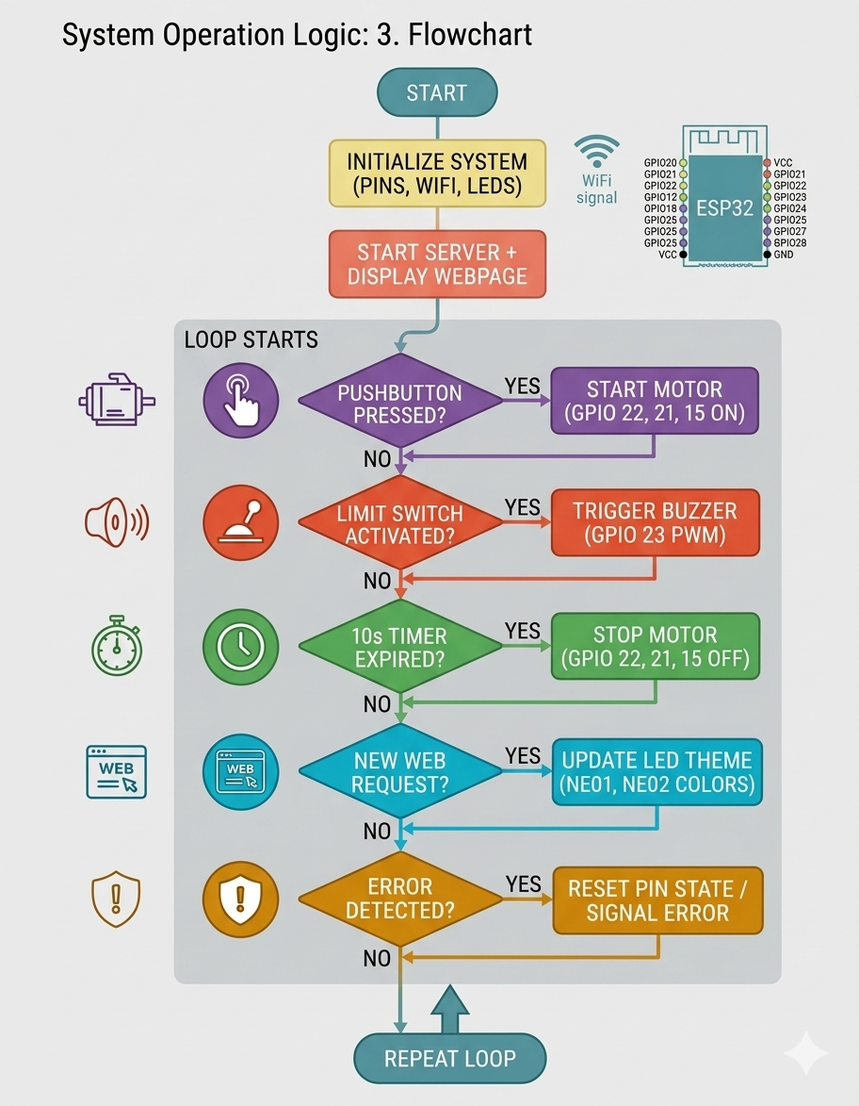

4. App / Web Flow

Screen Flow
- User connects to WiFi → Opens webpage
- Main screen shows theme selection cards
- Selected theme is highlighted

Button Actions
- Clicking a theme card:
  - Sends request: /theme/<theme_name>
  - Updates LED colors instantly

Data Flow
- Website → sends theme request → ESP32
- ESP32 → processes request → updates LEDs

